Tour Report – Berlin, Dresden, Prague to Vienna
May 3 – May 14, 2023
The day before the tour began most people had arrived in Berlin at the Eurostars Hotel on Friederichstrasse, to recover from jet lag before the tour started. The extra time was spent with people discovering the city’s museums, local areas and restaurants. We were all delighted at the Reception to meet Matthias, our Tour Manager, who was a Berlin native and who grew up in Communist East Berlin. Matthias was also our Berlin local guide and described to us how it was to live in such an oppressive system on the city tour the following day, especially when we looked at the parts of the Berlin Wall that had been left standing.
Our first opera performance was the next evening and we set out to walk to the Staatsoper about 10 minutes away from the hotel. The opera was Tannhauser and we were all anticipating hearing Lise Davidsen as Elisabeth. She did not disappoint and sang with beauty and power but many of us were irritated by the staging which included a modern ballet company very well known in Germany.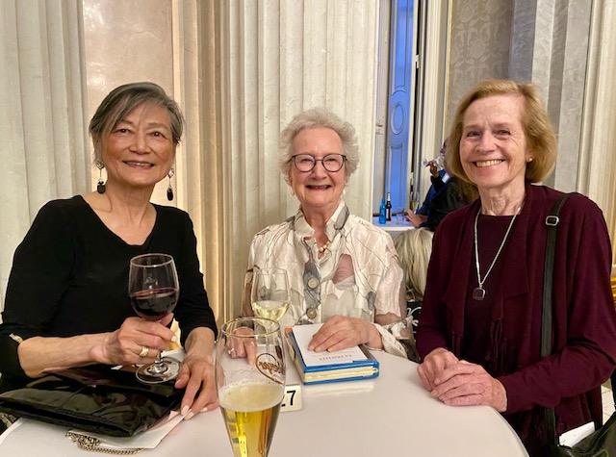
The German audience certainly seem to appreciate the ballet but it did seem distracting. The following evening after a day when people explored on their own and some of us took a river cruise around the city, we returned to the Staatsoper to see La Traviata with Irina Lungu, Freddie De Tommaso and Artur Rucinski. An announcement was made at the beginning of the performance that Freddie De Tommaso had a cold but would sing. He did very well and only the fact that he took lower notes at the beginning of the opera showed that he was unwell. It was a minimalist production that lacked colour but the singing was wonderful.
On Saturday May 6th, the morning of the Coronation in London, we left Berlin for the short drive to Dresden. On the way we stopped at a small highway rest stop and discovered that the Coronation was on German TV and we watched while we had coffee. A group of Germans arrived and asked for the sound to be put on and we heard Bryn Terfel singing in Welsh as part of the Abbey service. We arrived in Dresden around noon and found a fair taking place in the square outside the Steigenberger Hotel de Saxe where we were staying. Some of us were able to sample the typical German fast food (sausages and sauerkraut) for lunch before heading off for a walking tour of the old town where we were staying.
During the walking tour we learned that there was to be an organ concert that evening in the restored Frauenkirk close to the hotel and some of us were able to obtain tickets for this. It was a short but lovely concert which included both German and Italian baroque composers performed by a young woman who was a fine organist. 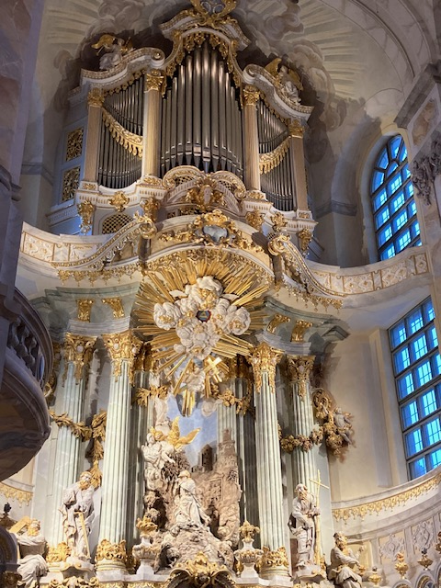
The next morning after breakfast the group dispersed, some to take a river cruise down the Elbe and some to explore one or more of the fine museums and treasures the city has before walking to the Semperoper House for a performance of Die Meistersinger von Nurnberg which began at 4pm. The opera house is lovely and has several bar areas on different levels that provided refreshments for the two intermissions. We had good seats in the orchestra area and enjoyed the performance which was in modern dress. Georg Zeppenfeld was Hans Sachs, Tomislav Muzek was Walter von Stolzing and Julia Kleiter was Eva. It was conducted by Christian Thielemann who, with the orchestra, received the loudest applause after a really magnificent performance.
The following day we set out for Prague - another short journey – arriving shortly after noon. As our rooms were not yet ready at the Grandium Hotel, just off Wenceslas Square, we were led by Matthias on a short walk of the Old Town to get our bearings. After getting our rooms we met in the hotel lobby to walk to the National Theatre where we were to see the first of our two opera performances, the Bartered Bride. The National Theatre is beautifully decorated and a delight to see. The opera performance was entertaining and a lot of fun! It involved treating the opera as if it were a rehearsal for the opera itself and with acrobats and dancers provided great entertainment and very good singing, although we could not find the names of the artists involved as several cast lists were published.
Our tour of Prague began with a bus to the Castle on the opposite side of the river to the Old Town. We walked through the castle area and down the hill where we took a tram to the Mala Strana (Lower town) where we walked across Charles Bridge to the Old Town Square in time for the 1pm Astrological Clock display.
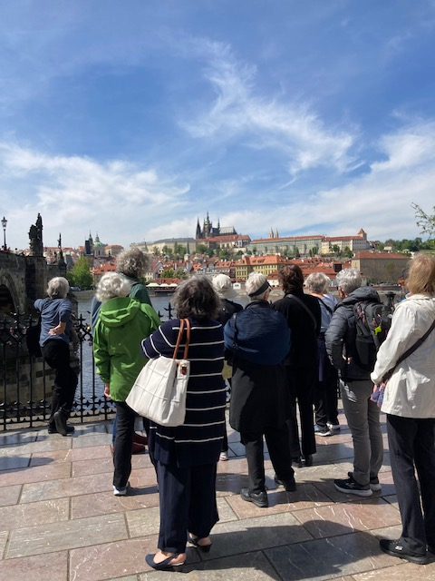
The rest of the day was for personal activities and there is so much to do in Prague. The next day, Wednesday, we were again free to organise personal activities until the evening when we had tickets to the Estates Theatre which was a short walk away from the hotel. The opera was Don Giovanni, which was premiered here by Mozart after the Marriage of Figaro received a better reception in Prague than in Vienna. This is a gem of a theatre! It must be quite a challenge to perform operas here as it is a listed building and changes, especially those that involve stage machinery of the type used today, are impossible to make. The opera was performed in a traditional way with much moving of back cloths and side curtains. Again, it was difficult to tell who was actually singing as several casts were listed.
On Thursday morning we left Prague for a three hour journey to Cesky Krumlov, en route to Vienna. Cesky krumlov is a town that has remained as it was in the 18thC and whose origin is long before that. The town exists within an incised meander of the Vlatava River ( Moldau) and a castle grew up on its outer bank. Wandering through the town through narrow lanes and traditional houses is like wandering through history. We were to make a special visit to the castle because it contains one of the two 18thC theatres in existence in Europe still able to house audiences and productions. (Sweden has the other). We had a fairly long walk up to the castle although some people were able to take taxis. We had a private English tour and were able to see, and hear the sound effect machines as well as those used to change scenery.
Another three hour drive, this time in the first rain we had seen on our tour, took us into Vienna to the Hotel Bristol in the old town, across from the Opera House. The rain continued the next day when we had our city tour so we spent most of the time on the bus and only the last hour walking in the old town by which time the rain had become a drizzle. As the hotel was just across the street from the opera we did not get too wet but everyone at the Staatsoper was required to check their coat. Our opera on Friday evening was Tosca with Bryn Terfel, whom we had last seen at the Coronation, Piotr Beczala and Maria Agresta. Fabulous!!! The opera stopped in the last Act as the audience demanded an encore of Piotr Beczala’s “E lucevan le stelle” before they would stop clapping – and he did just that! I think we all returned to the hotel several inches off the ground. Saturday was spent shopping, sightseeing, museum-hopping and then our final opera performance - Manon. Manon was to have been sung by Pretty Yende whom we had heard on an earlier tour to Pesaro in Italy a few years ago. Unfortunately she had withdrawn from the production after an accident we were told (although she did sing at the Coronation) and we had Else Dreisig who I notice often shares roles with Pretty Yende in Paris and Germany. As the opera opened, rather than the 18thC coaching Inn we had a train station in Paris and it progressed from there. The singing was first class but I don’t think that the production really drew us in as Tosca had the evening before. Sometimes modernization of the production touches a chord and sometimes it just doesn’t!
Before the final performance we had met in the bar of the Bristol Hotel to say goodbye to Matthias our knowledgeable and personable tour manager who had added so much to our knowledge and understanding of the places we visited. We were fortunate to have been able to see such a variety of very good opera performances and had good weather for all but the last couple of days. While most people returned to Canada the following day a few stayed on or travelled elsewhere.

Lis Dawson
Genny MacLean

