REPORT – VANCOUVER OPERA GUILD TOUR
NORTHERN ITALY AND SICILY OCT 12-24, 2022
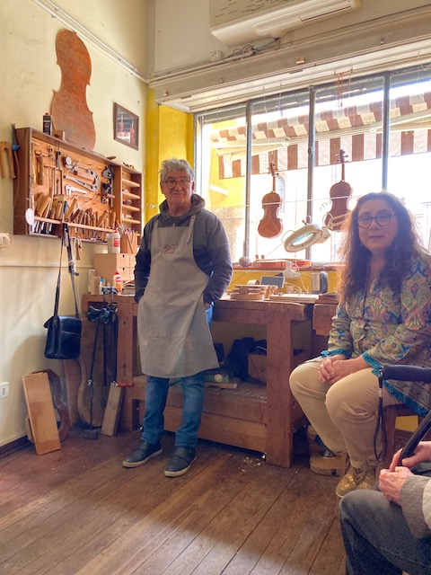
The people on the tour arrived from different routes and on different days but we all met in Milan on Wednesday Oct 12th at the reception in the Hotel Cavour in Milan. For those people who arrived before 4pm there was a tour of the La Scala Museum as an opera rehearsal closed the opera house itself. It was a lovely reception that took place in the main lounge of the hotel which had tables and very comfortable chairs. The food was lovely and included a local risotto so we really had dinner! After an early evening, we left for Parma by comfortable coach the next day, stopping in Cremona to visit the Violin Museum, a visit to a violin maker and for lunch.
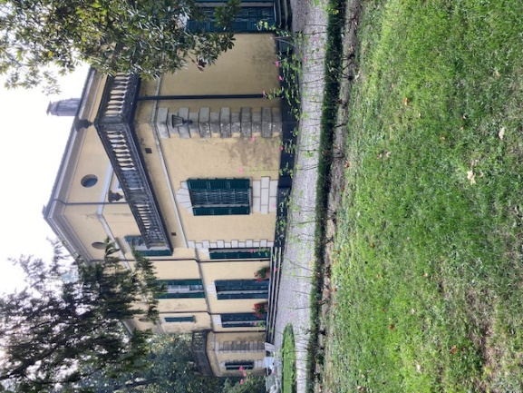
We arrived at the Hotel Maria Luigia in Parma in the late afternoon and settled in for 5 nights. The hotel had other opera groups staying there from the UK and the Netherlands and possibly other places. It was an easy walk from the hotel to the opera house along a well-used main street lined with restaurants. We visited Busseto where Verdi lived for much of his life and we had a guided tour of his Villa Agata and the grounds with a guide who was a friend of the present owners (Verdi’s nephew’s family). We had a guided tour of the Teatro Farnese and a backstage tour of the Teatro Regio where we saw the operas. The Teatro Farnese is amazing and possibly one of the oldest theatres in Europe – no longer used today. The backstage tour of the present theatre, Teatro Regio, was so interesting as were able to visit the workrooms and speak to the people who worked there and listen to the stories! We had free time too to visit places of interest in the city and many went to the Cathedral, the Baptistry or the museum showing the life of Maria Louisa who was the daughter of the Holy Roman Emperor and the wife of Napoleon. After Napoleon’s exile M-L was given the Duchy of Parma and it is due to her that the Teatro Regio and the cultural life of the area were developed.
Violin Maker in Cremona
We saw three musical works during the Verdi Festival. The first opera was Simon Boccanegra, an opera rarely seen in North America. The basic setting is Genoa in the 12thC when a new doge is to be elected and the conflict is between various political ideas. The director changed the setting to the Genoa port of the 1950s and the action took place, not in the Doge’s Palace but in an abattoir, between the unions and owners. Actually most of this made sense and made for interesting theatre but one scene where carcasses of newly killed animals hung down over the set was roundly booed! The singing was wonderful with Vladimir Stoyanov, Roberta Mategna and Ricardo Zanelleto singing the main roles.
Villa Agata
Quattro Pezzi Sacri and the overture from Parsifal were performed early evening on Saturday by E Coo del Maggio Fiorentina conducted by Dannielle Gatti. The orchestra and huge choir filled the stage. The overture to Parsifal was extended with other music from the opera including some chorus work and lasted 40 minutes – much longer than expected. It was followed by the sacred songs which were unknown to most of us and lovely to hear. The choir was magnificent and some of the musicians seem to have been placed in the Royal Box so the sound came from all directions. At the end of the performance we all rushed out to secure our dinner reservations.
The last opera was La Forza del Destino with Liudmyla Monastyrska, Gregory Kunde and Mongolian baritone, Amartuvshin Enkhbat singing the main roles. It was another wonderful evening. The artists we heard in Parma are not very well known in North America, with the exception of a couple of names, because they do not always travel to North America to work – there is enough work in Europe without the jet lag! However the artists are well known in Europe and it was lovely to hear fine singing and excellent productions. That said, I have noticed that the Mongolian baritone, who received such a long ovation after Forza, will be singing several roles this season at the MET.
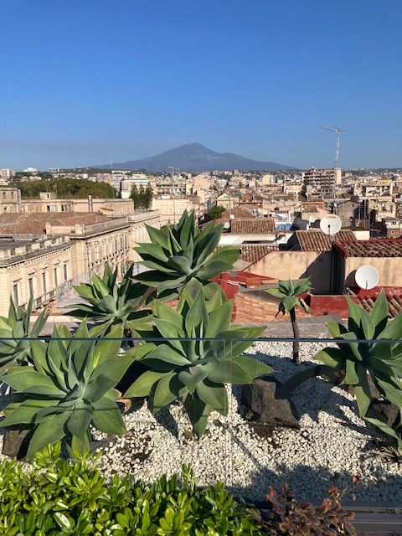
After the operas at the Verdi Festival we ended our visit to Parma with an excursion to Bologna not too far away. This is an old city with an ancient university, said to be the oldest in Europe. We had a guided walking tour of the old centre now a pedestrian zone and spent the remaining time exploring the town and having lunch with some people choosing Ragu Bolognese quite different from the “Spag Bol” that we often see here at home!
The following day we left for a journey to Milan’s Linate airport where we checked in and flew to Catania to start the Sicily portion of our tour. It was a beautiful day when we arrived in Catania after a pleasant flight. It was much warmer and sunnier than Parma although the weather had been good there too. A short drive brought us to our hotel in the centre of Catania, the Hotel Palace, which was indeed a converted palace. We settled in quickly, found the roof top bar where we went for a view of Mt Etna, the tallest volcano in Europe. Unfortunately the mountain, with its smoke, could really only be seen in the morning as we watched the clouds gradually rise up the slope during the day obscuring the volcano.
Mount Etna
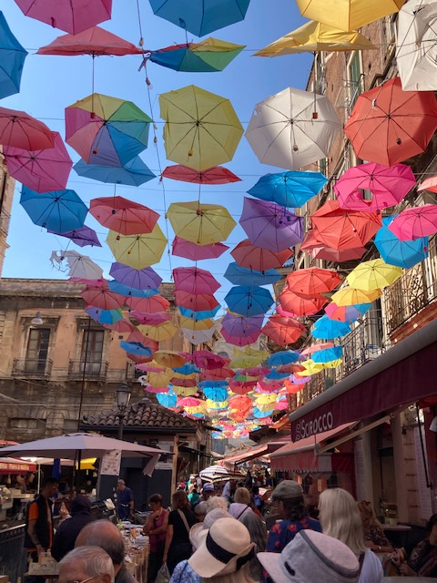
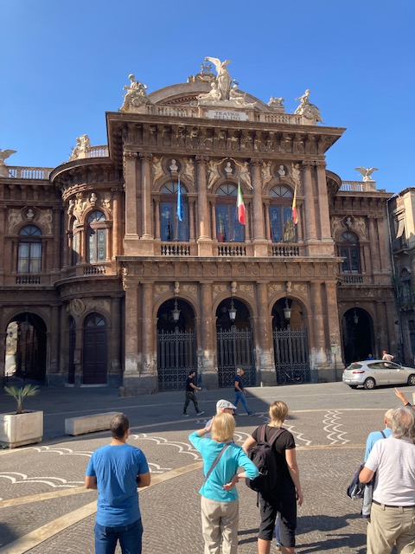
Our first day in Catania we had an optional tour of the Teatro Bellini. Originally we were to have seen an opera here but the date was changed (along with the opera) which did not help us. However they were rehearsing Tosca which was due to open the following week and we had a guided tour of the theatre. The theatre was lovely and is known for its acoustics and it was exciting to watch a small part of the rehearsal. Then we had free time to explore before climbing into two small buses for the trip to Taormina. The smaller buses were necessary because Taormina is way up the side of Mt Etna and the streets are very narrow. We spent the rest of the afternoon admiring the incredible views and wandering along the main street which was filled with designer stores and restaurants. After dinner in one of the many restaurants we found our way to the theatre for the opera concert and were greeted with a glass of Prosecco! The concert featuring a soprano, tenor and pianist (whose names I cannot find) was delightful and the final part was full of fun!
Catania Opera House
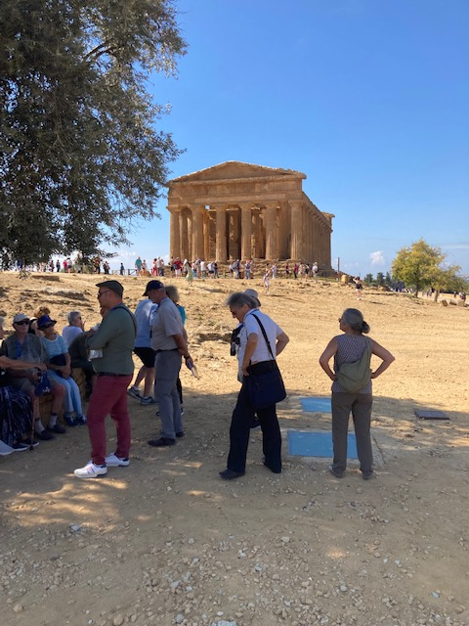
The following day we had a walking tour of the central square of Catania and the surrounding area including the fish market, regular market and the Norman fort. We enjoyed exploring Catania and found some lovely restaurants especially in the back street areas. Mostly we saw locals rather than tourists although an American tour group did arrive in our hotel. We liked to sit at the roof top bar watching for the volcano and enjoying the local wine or Negronis! Alas we needed to move on! We left Catania early Friday morning for the two hour ride in the coach to Agrigento. This is a World Heritage site on the south coast where there is a series of Greek temples - said to be the greatest outside of Greece, dating from the time of the Greek occupation of the eastern part of Sicily. We had an interesting guide for the walk among the temples and then had a lovely lunch beside the sea. Our coach journey from Agrigento to Palermo took about 3 hours and was one of the most memorable journeys that most of us have taken. The scenery between the mountains was absolutely beautiful with groves of vines and almond orchards. The roads were often elevated above the countryside and the ride was very smooth. Our guide, Sergio, whose father was originally from Sicily, told us that the government had spent a lot of money on the main roads but that the rural roads were very poor. We arrived in Palermo just before 6 pm. After the lovely ride Palermo looked quite chaotic but using the one way street system we eventually arrived at our new hotel, the Grand Hotel Wagner, a short walk from the Teatro Massimo where we were due to see Nabucco on Sunday evening.
Agrigento
Catania Market
The Grand Hotel Wagner was in a quiet street and a short walk along the street led to a broad avenue lined with restaurants spilling out into the road which had been converted into a pedestrian area. The hotel rooms were large and the public rooms were very comfortable. Down the street towards the water there was a small Anglican Church and several of the group went to the prayer service on Sunday morning and met the interesting congregation. The day before we had a bus tour to the cathedral in Monreale which is 1000 years old – a Norman building with an incredible byzantine interior. The little Anglican Church too had a byzantine apse that must be unique! Our walking tour that followed the visit to Monreale took us through the mainly Arab section of the city where a busy market was located and through the narrow streets of an old area.
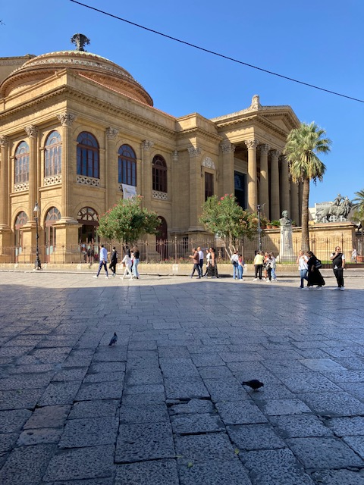
On Sunday morning after visiting the little church we had free time to wander around the city before arriving at the Teatro Massimo for the opening night of Nabucco which was also the opening of the Opera Season. The Teatro Massimo is large and imposing. The entrance is up a flight of stairs and the plaza in front was crowded with people watching others going in to the opera. There were several people with cameras taking pictures of those entering the theatre. Inside, the theatre is large too – the third largest in Europe after Vienna and Paris – and we had seats in the main floor. Nabucco is a very popular opera in Italy given its story about the Babylonian Captivity (and its relationship to the unification of Italy) and the chorus “Va Pensiero” so it was greeted enthusiastically. The singing was very, very good. Abigaille was sung by the Russian spinto soprano, Irina Moreva who has sung in many European cities and is well known. Nabucco was Alberto Gazele and Fenena was Silvia Beltrami. There was an encore for Va Pensiero as there usually is. The setting of the opera was not obvious. The principals were dressed well but of no particular time period but the chorus was generally dressed simply. The production was minimal but there were two intermissions because (I believe) the stage had to be moved/changed by hand. What was noticeable was the general behavior of the audience. I am sure it was the worst behaved audience that most of us have seen. In Parma it was so quiet during the performances but here many people arrived in their seats late – after the beginning of the act, not just once but after both intermissions too. People behind us talked all through the opera and cell phones were used to record the performance. We did ask our guide why the theatre didn’t ask people to turn off cell phones as other theatres did. He shrugged and said “Sicilians! They wouldn’t obey anyway!”
Teatro Massimo
We left Sicily the following day some returning home and a small group of 8 travelling on to Milan for a performance at La Scala. The Milan group returned to Hotel Cavour and attended Fedora that same evening. It is always exciting to go to La Scala and indeed it was a wonderful production with Sonia Yoncheva as Fedora and Fabio Sartori as Ivanov, a production that will be seen at the MET in 2023. After Palermo we wondered what the audience would be like? Well this was an international audience and, apart from a young couple seated in front of us who tried to use a cell phone to take a photo during the performance, the audience was very well behaved – no booing from the high galleries! Perhaps it is just Sicilians!
Now that we have all returned home we have wonderful memories of interesting productions and wonderful singing – as we expected. We all loved Sicily: the scenery, the towns and cities, and the food – no one had a bad meal in Sicily. Our hotels were all very comfortable and well located and we were fortunate not to have experienced the travel disruptions that we heard of during the summer. Thanks to our Tour Manager Sergio who travelled with us and to all the wonderful local guides who were so knowledgeable and patient. We saw a lot and learned a great deal.

