REPORT – VANCOUVER OPERA GUILD TOUR
ENGLAND JUNE 21-JULY 2, 2022
With a UK rail strike due to begin the day of the opera tour some people had a long journey from Heathrow to the Strand Palace Hotel but the Reception was splendid when they arrived with enough food and drink to make sure the party lasted for a few hours and served as dinner too! The rail strike caused traffic jams the following day when we left the Strand Palace for the journey to Tetbury, Gloucestershire, where we were due to pick up more of our group before travelling a few miles more to Highgrove House to visit Prince Charles’ garden. It was a hot sunny day and we spent our time in the garden with a guide who had interesting stories. We finished up in the Garden Shop. Unfortunately we had no time to stop for tea as we were due in Oxford where we were to stay for the next three days.
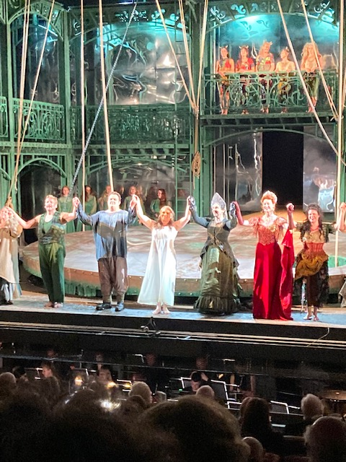
Our first opera festival was at Garsington, one of the Getty Family estates, which is a few miles from Oxford. We left Oxford in the afternoon so we could arrive at Garsington by 4pm for a 5pm start to the opera, and we could see the gardens. The place is much the same as it was on our first visit about 10 years ago but it now does have an elevator up to the theatre and it has permanent side walls – so it was warmer! We had really good seats for Rusalka which was such an interesting production. The set was designed to invoke the life of the water spirits as well as life on land in this popular fairy tale. It made imaginative use of a moveable platform that illustrated the divide between the two worlds. The lower world was filled with water through which the water sprites moved. At one point Rusalka slipped in the water and fell on her back but immediately shouted “I’m Ok !” and signaled the conductor to continue!
Natalia Romaniw, with a deeply expressive voice showing power and beauty, was the water sprite who sacrifices everything to follow the prince she loves into the human world. We heard two covers as Vodnick, Rusalka’s father, Henry Waddington, and the Prince, John Findon. They were both excellent. Christine Rice was Jezibaba. The ending of the opera was very moving.
At Garsinton we had a very English picnic, fortunately in a tent, as the weather turned inclement with rain and wind. It was still raining as the opera finished but we did not have to walk too far to our bus.
While we were in Oxford we had an interesting walking tour from our hotel, Mercure East Gate, which took us through side streets to the Radcliffe Camera and concluded with a visit to Magdalen College. Some of us found one of the oldest pubs in Oxford (often used in Morse films) and were able to have dinner there among all the students. The Ashmolean Museum is also very interesting and seems to have been much updated. It has a lovely cafeteria, a roof top restaurant and an interesting gift shop.
From Oxford we moved to Salisbury, via Winchester, where we had a wonderful guide. She was a retired head teacher, who showed us the ancient buildings that formed the Royal residences when Winchester was the capital of these Saxon lands during King Alfred’s time, the ruins of the castle where Mary Tudor married Philip of Spain as well as Winchester Cathedral. She also recommended a place with the best fish and chips, we all agreed, we had eaten in some time! After Winchester we moved to our hotel in Salisbury, the Red Lion, which, we discovered, dated from a dormitory for the stone workers who built Salisbury Cathedral close by in the 12th century! As there was no working elevator it took some time for us to sort ourselves out but eventually we did and our luggage was carried up by the young workers all who seemed to be in training!
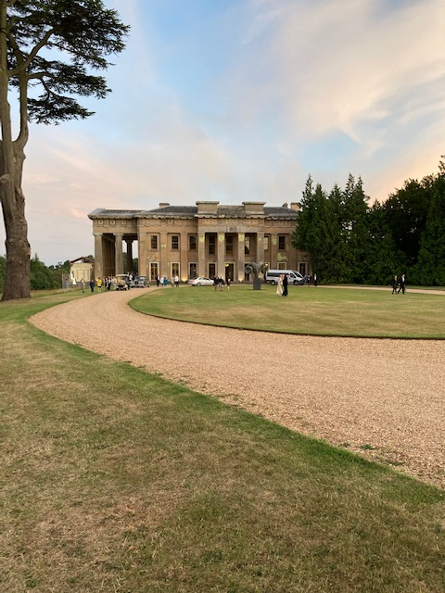
We were not due at our next opera festival until the next evening so some of us walked to the Cathedral for Evensong which took place in the Choir area with a small but beautiful choir and a lovely organ dismissal. The next morning some went to the 10:30 service which filled the Nave, again with the choir, organ and sung responses. We passed by M&S on the way back to the hotel which provided lovely food for our “picnic” lunches! The Grange Festival takes place in the house owned by the Baring family. It is unoccupied because it suffered a fire, thought to be deliberately set for the insurance money, about 25 years ago! The operas take place in a well-appointed and comfortable theatre built in the former conservatory while the dinners are served in the damaged rooms! The tables were all beautifully set and the food was delicious! The house is set in a vast estate and to reach it we needed to navigate our way through very narrow country lanes to find the “truck route’ into the estate that our very large bus needed to use. Fortunately, after a misdirection caused by poor signage, we followed a car that took us quite a roundabout way to the entrance to the drive way. Thanks to the skill of our bus driver, Su, we made it through the gates without incident. Nor was it to be that last time that Su faced challenges driving a very large bus through some of the most rural parts of England. This turned out to be a very real treat for us as we saw some of the loveliest countryside and gorgeous villages and houses that we don’t see when we travel on the main roads.
The opera we saw at the Grange Festival was Gilbert and Sullivan’s The Yeoman of the Guard, said to be G&S’s most serious opera. It had one set, the Tower of London and the story is a tragic/comedy between a merry man and a maid and a prisoner in the Tower who is due to be executed. It is a skillful mix of comedy, sentimentality and possibly tragedy! The opera is originally set in the time of the Civil War in the 1640s but without changing the story it was updated with a light touch as the costumes were from the end of WW1 so brought the story more up to date. The singing and the acting were excellent with Nick Haverson as Jack Point, the merryman; Nick Pritchard played Colonel Fairfax, the prisoner of the Tower; Ellie Laugharne was Elsie, the maid; Angela Simkin sang Pheobe and Heather Shipp was Dame Carruthers.
The following day we had an excursion to Avebury which is the largest prehistoric monument in the UK and then on to Wilton House, home of the present family of the earl of Pembroke. The village of Avebury is set in the middle of the stones and so it is possible to see the stones and wander among them here, unlike Stonehenge a few miles away. We also were able to see the difference between a manor house (Avebury Manor) and a stately home (Wilton House). We wandered around Avebury Manor which is administered by the National Trust but at Wilton House we were taken around by a very knowledgeable guide as this is private and home to the Pembroke family. The drawing rooms with their fine furnishings and paintings were particularly interesting.
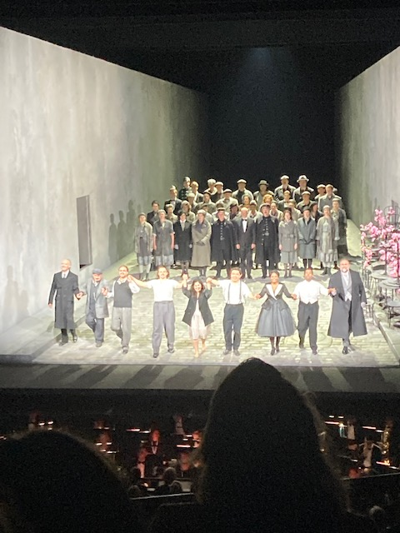
From Salisbury we moved on to Brighton following roads that took us through the beautiful English countryside and coast. Our hotel in Brighton, Jury’s Inn, occupies a splendid location right on the Brighton promenade. At the back of the hotel are The Lanes, narrow streets that formed the old town and now offer a variety of small specialist shops and restaurants. The Pier and the Regency buildings are a short walk away. We left the hotel after changing our clothes for we were due at Glyndebourne for the evening’s opera, La Boheme. Glyndebourne is still a family home but it is one of the oldest opera festivals. The grounds are lovely and we watched people who had arrived in their cars set up the picnics they would have during the long interval (we ate in one of the restaurants). This production of La Boheme is the first new production of this opera in 20 years and is a dark spin on the doomed lovers. The set is a street with monochromal colours. Death appears as a character. The production provided a great deal of discussion after the opera as we are so used to seeing the romantic side of La Boheme with the bohemians living in a garret. The singers wore modern clothes so it suggested that they were the street people we see every day in Vancouver and London! The cast was international and absolutely top notch. Rudolfo was the Chinese lyric tenor Long Long who has been singing with several German opera companies and Salzburg but who almost missed the production when his UK visa was delayed! Mimi was the Chilean soprano, Yaritza Veliz who came to the Uk as part of the Jette Young Artists programme run by the Royal Opera. Musetta was the South African soprano Vuvu Mpofa who, in 2021, won the John Christie Glyndebourne Award. It was a riveting performance even if it caused uncomfortable feelings.
Before the last opera festival Grange Park in West Horsley, Surrey, we had an excursion from Brighton to Petworth House, a stately home now belonging to the National Trust, which contains perhaps the best collection of great paintings in private hands. The house dates back to Tudor times but most of it is from the 18th century and that is the time period that the National Trust has used to display the paintings. The grounds of the house are also interesting as they were laid out by Capability Brown also in the 18th century. The servants quarters have been converted into an education centre, lovely cafeteria and well stocked shop (and toilets of course!)
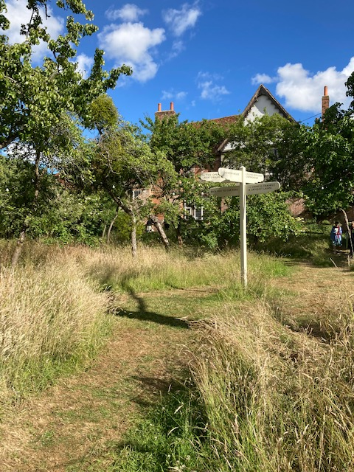
Our final opera was Otello with Sir Simon Keenlyside as Iago, Gwyn Hughes-Jones as Otello and Elizabeth Llewellyn as Desdemona. The scenery was simple and the costumes had been updated to a blend of Mussolini Fascist Italy and the British Colonial past on Cyprus. It was also a colour-blind casting with Otello who is white and Desdemona who is black. The voices were wonderful but the stage was dominated by the silent, watchful performance of Simon Keenlyside who really dominated the opera whenever he appeared. It was wonderful and so was West Horsley House which is a lovely old home (dating from 16thC). While the opera takes place in a specially built theatre, we ate a lovely dinner in the house, in the Red Room which was upstairs in a beautifully panelled room hung with family portraits.
One memorable incident before the opera began was when the founder of the Grange Park Opera Festival appeared on the stage to ask for donations for an Arts Foundation set up in the name of the owner of the house (Bamber Gasgoine) who had died in February . She mentioned the fact that in 2021 Grange Park had produced a new opera based on the life of Putin which had been criticized because it showed Putin as evil! Before we knew it she had us all shouting out “Putin is Evil” – twice because the first time it was not loud enough!
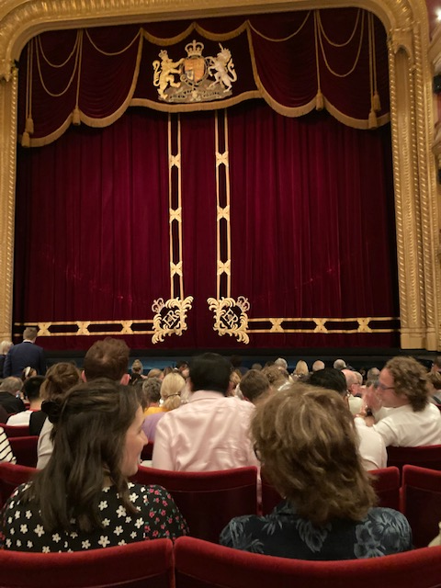
Our final bus journey was back into London and the Strand Palace Hotel for our final night in London and our last opera. This was Mozart’s Cosi fan Tutte. We had wonderful seats in the stalls and the opera was a great romp. It was a production from 2016 which was hailed as “Mozart’s witty and compassionate examination of young life” This opera’s subject is always problematic but not the music! All the singers gave wonderful performances even if we didn’t quite understand what was going on. There was so much activity on the stage that there was a choice to be made: enjoy the singing and the music or look at the surtitles and miss the action – which actually started in the Stalls Circle and moved onto the stage. The singers were young and full of energy. Jennifer Davis was Fiordiligi, (Canadian) Julie Bouliane was a sassy Dorabella; Bogdan Volkof was Ferrando and (Canadian) Gordon Bintner was a confident Guiliemo. It was conducted by Julia Jones.
And so the tour drew to an end. We had some memorable opera experiences in lovely buildings and lovely meals. The unexpected pleasure was the beauty of the English countryside seen from the elevation of a large bus which provided an unusual perspective you do not see when driving in a car.
The tour raised $7.100. for your scholarship, awards and bursary programmes.

