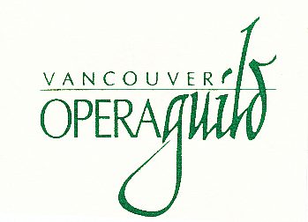

Vancouver Opera Guild

2023 Career Development Grant – Production/Technical
($6,000)

These materials must be included with your application:

1. Proof of age and citizenship – birth certificate, passport, driver’s
licence etc.

2. Detailed description of your project:

• scope

• time to complete

• results sought

• purpose to which the grant will be applied

• a brief statement of other resources available for the project

3. Budget – your total cost should include where applicable:

• registration costs

• all travel expenses

• accommodation

• meals

• travel insurance (if applicable)

4. Portfolio: include an outline and/or sketches or samples of your most recent work
(if applicable).

5. Current letters of reference (2) – from two established professionals in the field -
e.g. stage directors, costume designers, lighting directors, specialists in your
field of opera, etc.

6. Curriculum vitae:

• must include a recent photo/headshot – minimum size 6” X 8” (preferred size: 8-1/2” X 11”)

